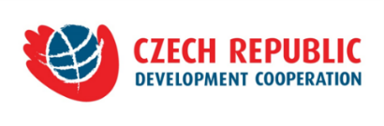
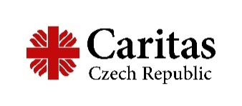

Request for Proposals to Procure Medical Devices and Furniture
Published: July 18, 2022 / Deadline: August 3, 2022
Attached Files: application form, declaration, budget form

Caritas Czech Republic (CCR) is an international NGO, working in several countries to implement developmental projects. In Georgia CCR has been working since 2008 and in 2015 it established its branch office in Tbilisi (CCRG), through which it implements various donor funded projects in the field of Social care, Healthcare, Environmental Care and Rural development. For more information, visit our pages:
https://www.facebook.com/CCRGeorgia2015/
https://georgia.charita.cz/

Caritas Czech Republic, with the financial support of the Czech Ministry of Interior, under the MEDEVAC program, opens invitation to interested, qualified parties to submit bids on supply of medical devices and furniture (in compliance with the annexed specification – #3), in the frame of the project “Improving gynecologic cancer care in West Georgia”. The project is being implemented in partnership with Georgian Medical Holding, under the Ministry of IDPsLHSAG.

Estimate cost:
Requested budget shall not exceed USD 150 000 (One hundred fifty thousand United States Dollars), including all taxes set forth in Georgian legislation, also transportation, training and order installation costs.

Delivery place: Rukhi and Batumi

Payment:
Payment will be done in the Georgian National Currency, by the exchange rate of the National Bank of Georgia on the day of the payment.

Estimated time: the delivery shall take place within 70 (seventy) calendar days after conclusion of a contract between contracting Parties.

Assessment criteria and criteria value:
- Quality of submitted application - 20%
- Experience and qualification of the bidder - 20%
- Cost of the proposal - 20%
- Delivery time - 20%
- Warranty period -20%

Environmental policy: CCR adheres to the environmentally-conscious principle and calls forth its subcontractors to follow this policy in order to reduce the nature and scale of impact of its activities on the environmental and human health.
Within the procurement of medical devices and furniture CCR will pay great attention to the quality of the devices and furniture to ensure the safety and efficacy of the products and minimize the risk of the harm to the users. Further, the supplier should pay attention to the product utilization impact on the environment and reduction of this impact through such factors as energy consumption (energy-saving, power management), repairability and commercial warranty, end of life management (recyclability), etc. considering the 3R principle of – “reduce, reuse, recycle”.

Submission of the bid - required documents:
- Completed Annex - Application form in Georgian and English (Annex #1), completed, signed and stamped;
- Completed and signed Declaration of the Conflict of Interest (Annex #2);
- Completed and signed Budget Form in Excel (Annex #3) providing detailed specification of medical devices and furniture. Technical passports of the devices and furniture shall be annexed;
- CVs (in English) of the purchase Manager and medical engineer, showing qualification and experience in the field;
- Extract from the public register (for the last 6 months), Georgian and English versions.

Please note, that incomplete application will not be considered. The proposals (Annexes 1,2,3) should be submitted in the Georgian and English languages.

The deadline for submission of proposals: August 3, 2022, 18:00 (Georgian time).The proposals shall be received electronically to: ccrg.vacancy@gmail.com and tamar.kurtanidze@caritas.cz
Please indicate in the subject line “Bid - Medical Devices and Furniture”.

Note:
- Proposals will be reviewed upon receipt.
- Selected candidates will be invited for interview within 5 days after completion of the bidding process.
- CCR retains the right to cancel the tender any time without a feedback to the applicants.

